Mary in the Redemption: A Global Perspective
Symposium of the International Marian Association
Ave Maria University, Florida
Friday, September 14 and Saturday, September 15

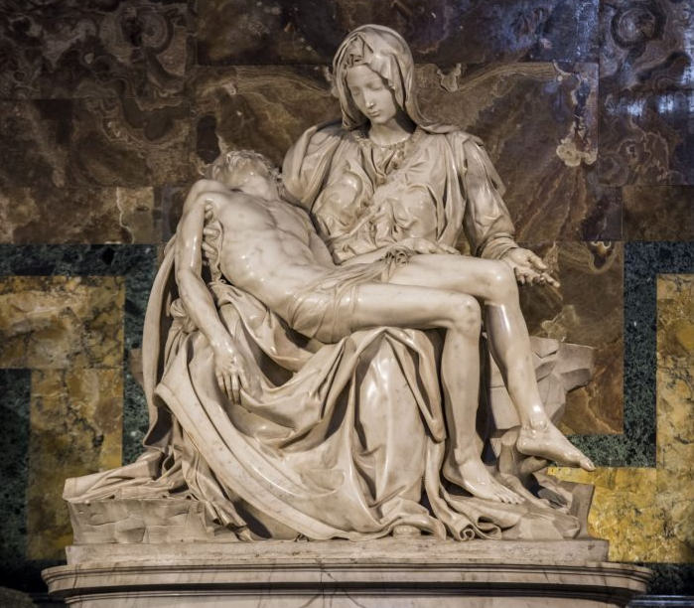

FRIDAY SCHEDULE, September 14, 2018

8:30-9:00am – Sorrowful Mysteries of the Rosary (Prince Building)
9:00-9:10am – Dr. Mark Miravalle, President, International Marian Association, Greeting and Opening Comments
9:10-10:00am – Most Reverend David Ricken, Bishop of Green Bay –“Our Lady of Good Help”
10:00-10:45am – Dr. Robert Fastiggi, Professor of Mariology, Sacred Heart Major Seminary, Detroit, MI – “The Theology of Mary in the Redemption”
10:50-11:00am – Break
11:00-11:45am – Mr. Joshua Mazrin, Director of Evangelization, Diocese of Venice, FL – “Mary in the Redemption, the New Evangelization, and the Youth”
12:00pm – Holy Mass: Most Reverend Frank Dewane, Bishop of Venice – Main Celebrant (Ave Maria Parish Church)
12:45-1:30pm – Lunch
1:30-2:00pm – His Eminence, Cardinal Toppo, Archbishop of Ranchi, India – “Mary in the Redemption: The Asian Perspective”
(Presentation by Father Dennis Cooney)
2:00-2:45pm – Testimonies to the Mother of All Peoples
3:00-4:00pm – Eucharistic Holy Hour (Father Dennis Cooney)
4:00-4:15pm – Break
4:15-5:00pm – Dr. John-Mark Miravalle, Professor of Mariology, Mount St Mary’s Seminary, Emmitsburg, MD – “The Reasonability of Mary in the Redemption”

End of Symposium, Day 1

SATURDAY SCHEDULE, September 15, 2018

8:30-9:00am – Joyful Mysteries of the Rosary (Ave Maria Parish Church)
9:00-9:45am – Holy Mass: Most Reverend Oliver Doeme, Bishop of Maiduguri, Nigeria
10:10-10:15am – Dr. Mark Miravalle, Opening Comments
10:15-11:00 – Most Reverend Oliver Doeme, Bishop of Maiduguri, Nigeria – “Mary in the Redemption: The African Perspective”
11:00-11:45am – Father Agustin Gimenez-Gonzalez, Professor of Old Testament, Universidad Eclesiastica San Damaso, Madrid, Spain – “Mary in the Redemption: The Spanish Perspective”
11:45-12:00pm – Letters from the World’s Bishops Regarding “The Mother of All Peoples,” (Read by Father Dennis Cooney)
12:00-1:30pm – Lunch
1:30-2:15pm – His Eminence, Juan Cardinal Sandoval, Archbishop Emeritus of Gudalajara, Presentation: “From Tepeyac to Amsterdam”
(Delivered by Dr. Luis Bejar)
2:15-2:45pm - Father Jan Kosiar, Doctor of Mariology – “Mary in the Redemption: The Eastern European Perspective”
3:00-3:15pm – Chaplet of Divine Mercy (Father Dennis Cooney)
3:15-4:15pm – Dr. Mark Miravalle, St. John Paul II Chair of Mariology, Franciscan University of Steubenville; Fellow of Marian Studies, Ave Maria University – “Mary in the Redemption: A Global Perspective”
4:15-6:15pm – Dinner Break
6:30-7:15pm – Mother Miriam (Rosalind Moss), Mother Superior and Foundress of the Daughters of Mary, Mother of Israel’s Hope – “Mary in the Redemption: Relevance for Today”
7:15-7:30pm – Eucharistic Rosary Procession
7:30pm – Eucharistic Holy Hour (Ave Maria Parish Church)

End of Symposium

